ADAPTIVE LEARNING INTELLIGENCE PLATFORM USING EDUCATIONAL DOCUMENT ANALYSIS AND PERSONALIZED LEARNING ANALYTICS
Block Diagrams (all)
Department of Computer Science and Engineering, TKR College of Engineering & Technology
Batch A1 (CSE-A) · Academic year [ACADEMIC YEAR]
Table 1: Project team
S.No. | Student name | Roll number
1 | A Dhanush | 23K91A0501
2 | Ale Vijayalaxmi | 23K91A0508
3 | Burri Mallikarjun | 23K91A0549
4 | Atragada Nagatrimurthulu | 23K91A0517

Project guide: Raghavendra
Chapter and section numbers quoted in the text (for example Chapter 8 or Section 6.2) refer to the full project report, 17.Final Document. Figures and tables in this document are numbered from 1.

1. INDEX OF DIAGRAMS
Every diagram was generated from the real design by scripts/make_diagrams.py (matplotlib, 150 dpi) and mirrors the code in backend/main.py, app.py and src/. The system has no SQL database, so the entity-relationship diagram shows the logical data model of the CSV and pickle files.
Table 2: Diagrams in this document
No. | Diagram | Image file
1 | System architecture | docs/diagrams/01_system_architecture.png
2 | High-level workflow | docs/diagrams/02_high_level_workflow.png
3 | Data flow diagram, level 0 | docs/diagrams/03_dfd_level0.png
4 | Data flow diagram, level 1 | docs/diagrams/04_dfd_level1.png
5 | Data flow diagram, level 2: document analysis | docs/diagrams/05_dfd_level2_documents.png
6 | Data flow diagram, level 2: answering questions | docs/diagrams/06_dfd_level2_rag.png
7 | UML class diagram | docs/diagrams/07_uml_class_diagram.png
8 | Sequence diagram: upload | docs/diagrams/08_sequence_upload.png
9 | Sequence diagram: ask a question | docs/diagrams/09_sequence_ask.png
10 | Use case diagram | docs/diagrams/10_use_case_diagram.png
11 | Entity-relationship diagram | docs/diagrams/11_er_diagram.png
12 | Flowchart: answering a question | docs/diagrams/12_flowchart_rag.png
13 | Flowcharts: quiz generation and roadmap | docs/diagrams/13_flowchart_quiz_roadmap.png

2. DIAGRAMS

System architecture
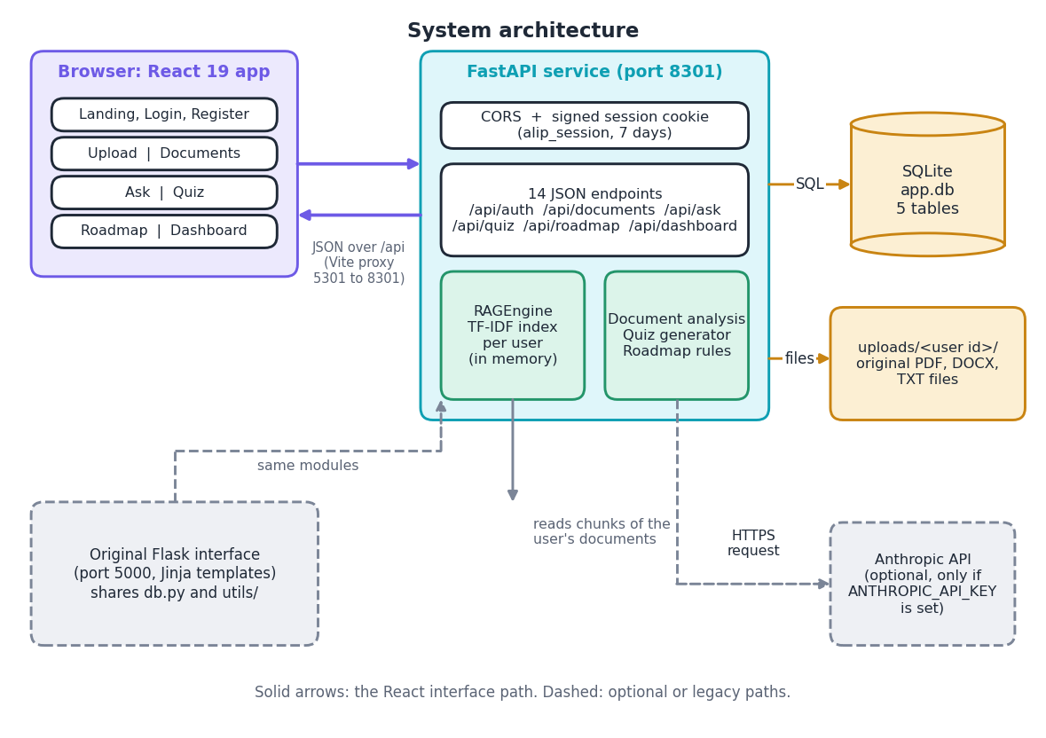
Figure 1: System architecture of the Adaptive Learning Intelligence Platform: browser, FastAPI service, SQLite and the file store.
The diagram has three columns. On the left is the browser, which runs the React 19 single-page application with its landing, login, register, upload, documents, ask, quiz, roadmap and dashboard pages. In the middle is the FastAPI service on port 8301. It applies two middleware layers (a CORS rule that admits only the front-end origin, and a signed session cookie named alip_session valid for seven days) and exposes 14 JSON endpoints under /api. Inside the service sit the two groups of logic: the RAGEngine that holds one TF-IDF index per user in memory, and the document analysis, quiz generator and roadmap rules. On the right are the stores: the SQLite file instance/app.db with five tables, and the uploaded originals under uploads/<user id>/. During development the Vite server on port 5301 proxies /api to port 8301, so the browser sees one origin. Two dashed paths are optional: the call to the Anthropic API, made only when ANTHROPIC_API_KEY is set, and the original Flask interface on port 5000, which imports the same db.py and utils/ modules and therefore cannot drift from the new interface.

High-level workflow
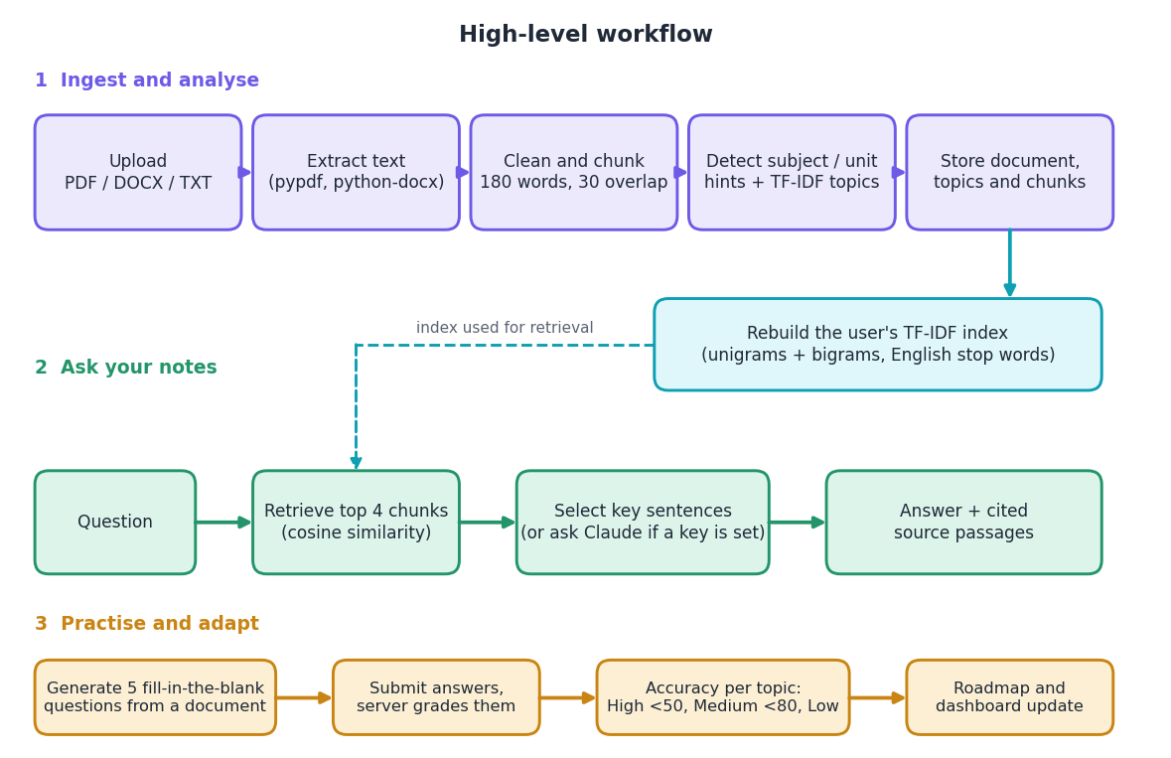
Figure 2: High-level workflow: ingest and analyse, ask, then practise and adapt.
The workflow has three stages. In the first stage an uploaded file is parsed (pypdf for PDF, python-docx for DOCX, plain reading for TXT), cleaned, cut into 180-word chunks with a 30-word overlap, scanned for subject and unit headings, given up to twelve TF-IDF topics, and stored; storing triggers a rebuild of the user's TF-IDF index (unigrams and bigrams, English stop words). In the second stage a question is vectorised with the same index, the four most similar chunks are retrieved by cosine similarity, and either the key sentences are selected or, if a key is configured, the chunks are sent to the language model; the answer is shown together with the source passages. The dashed arrow shows that retrieval depends on the index built in the first stage. In the third stage five fill-in-the-blank questions are generated from a document, the server grades the submitted answers, accuracy per topic is computed and the thresholds below 50 and below 80 percent give High, Medium and Low priority, which update the roadmap and the dashboard.

Data flow diagram, level 0
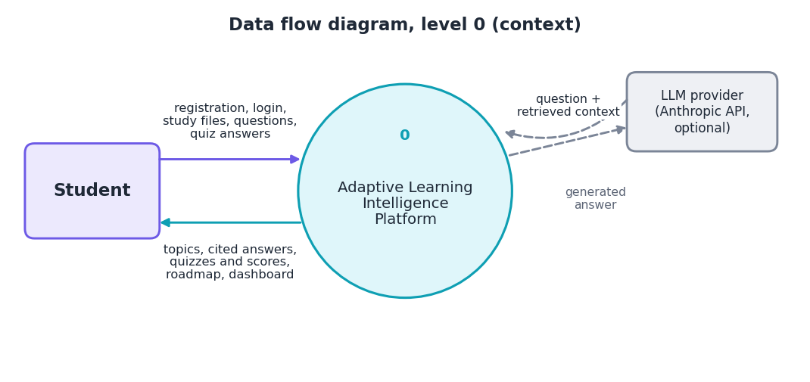
Figure 3: Level 0 data flow diagram (context diagram).
At level 0 the platform is one process. The student sends registration and login details, study files, questions and quiz answers, and receives the detected topics, cited answers, quizzes and scores, the roadmap and the dashboard. The only other external entity is the language-model provider: when enabled, the platform sends the question and the retrieved context and receives generated answer text. The dashed lines mark this flow as optional.

Data flow diagram, level 1
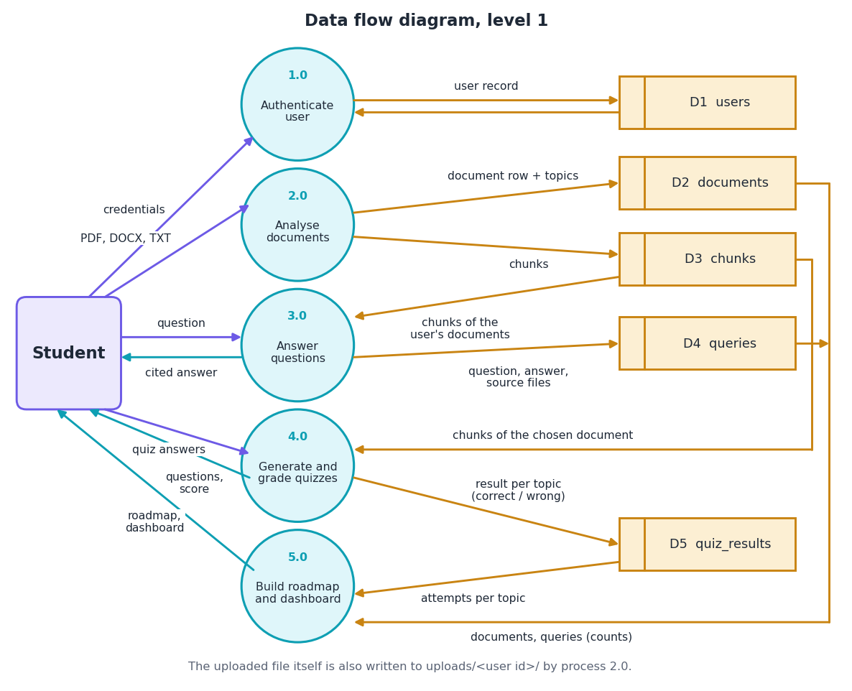
Figure 4: Level 1 data flow diagram with five processes and five data stores.
Level 1 splits the platform into five processes. Process 1.0 authenticates the user against D1 (users). Process 2.0 analyses documents and writes the document row with its topics to D2 and the chunks to D3; the uploaded file is also written to disk. Process 3.0 answers questions by reading the user's chunks from D3 and writing the question, answer and source file names to D4 (queries). Process 4.0 reads the chunks of the chosen document from D3 to build questions and writes one result per question and topic to D5 (quiz_results). Process 5.0 builds the roadmap and the dashboard from the attempts in D5 and the counts in D2 and D4. The long line on the right edge shows that processes 4.0 and 5.0 reach stores that are drawn beside other processes.

Data flow diagram, level 2: document analysis
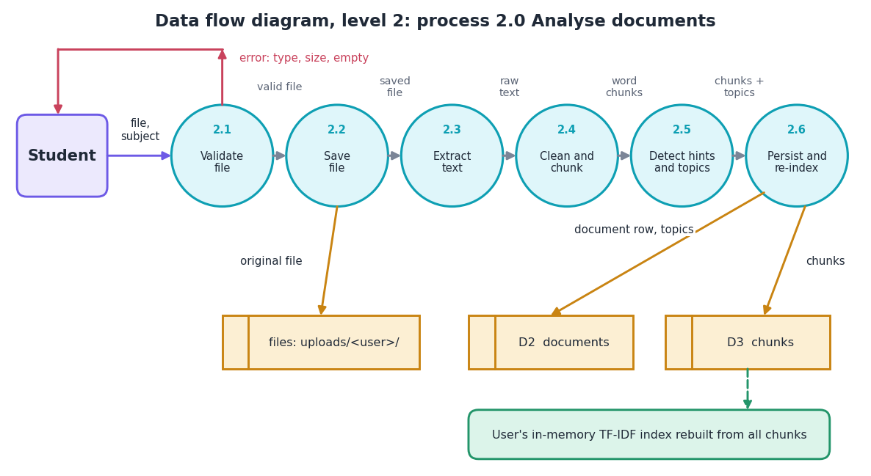
Figure 5: Level 2 data flow diagram of process 2.0, analyse documents.
Process 2.0 consists of six steps in a chain. 2.1 validates the file (extension must be pdf, docx or txt, size at most 16 MB, name made safe); a failure returns an error message to the student. 2.2 saves the original file under uploads/<user id>/. 2.3 extracts the raw text. 2.4 collapses whitespace and cuts the text into overlapping chunks. 2.5 looks for subject and unit headings and ranks TF-IDF terms, giving at most twelve topics. 2.6 stores the document row with its topics in D2 and the chunks in D3, and rebuilds the user's in-memory TF-IDF index from all chunks.

Data flow diagram, level 2: answering questions
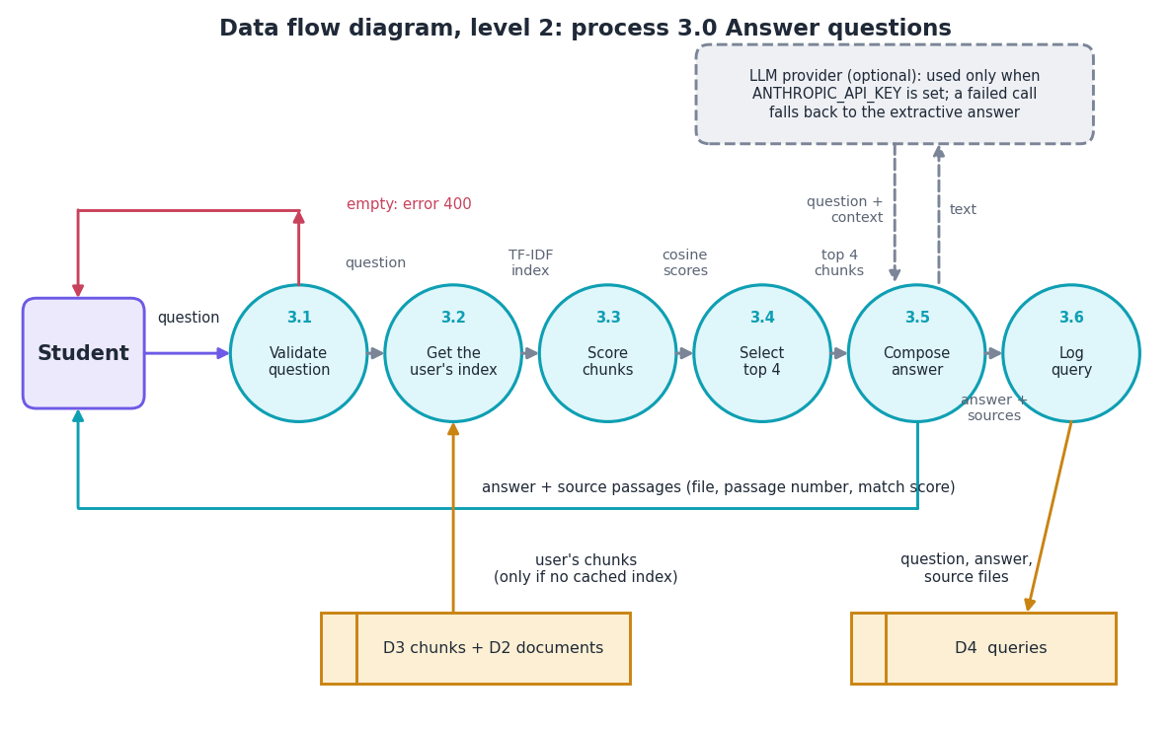
Figure 6: Level 2 data flow diagram of process 3.0, answer questions.
Process 3.0 is also a chain of six steps. 3.1 rejects an empty question with error 400. 3.2 obtains the user's index: the cached engine if present, otherwise the chunks are read from D3 and D2 and the index is built. 3.3 vectorises the question and scores every chunk by cosine similarity. 3.4 keeps the four best chunks with a score above zero. 3.5 composes the answer, either by selecting key sentences or by calling the optional language model (any failure falls back to the extractive answer). 3.6 stores the question, answer and source file names in D4 and returns the answer with the source passages, their passage numbers and match scores to the student.

UML class diagram
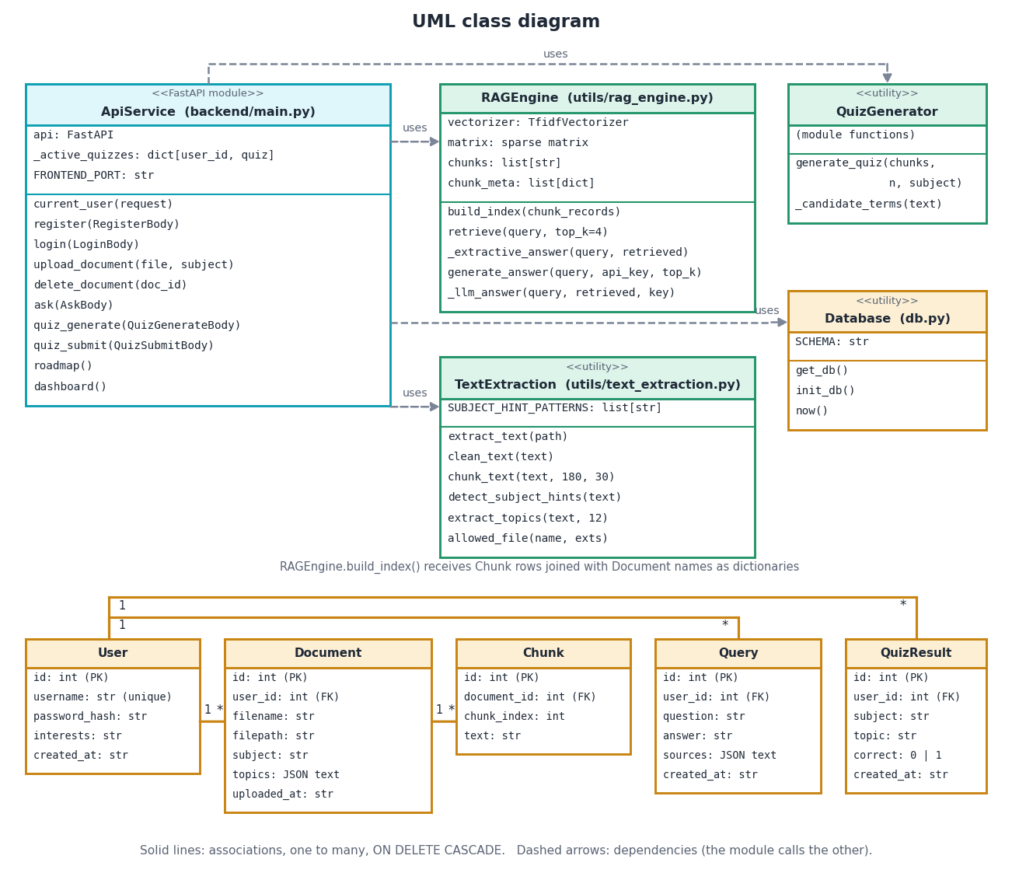
Figure 7: UML class diagram of the service modules and the five entities.
The upper part shows the code modules drawn as classes. ApiService (the module backend/main.py) holds the FastAPI object and the dictionary of quizzes in progress, and offers one function per endpoint; it uses RAGEngine, QuizGenerator and Database, and the helper TextExtraction. RAGEngine has a vectorizer, a matrix, the chunk texts and their metadata, and the methods build_index, retrieve, _extractive_answer, generate_answer and _llm_answer. TextExtraction, QuizGenerator and Database are modules of functions. The lower part shows the five entities with their key attributes. A user has many documents, queries and quiz results; a document has many chunks. The same relationships appear in the ER diagram.

Sequence diagram: upload
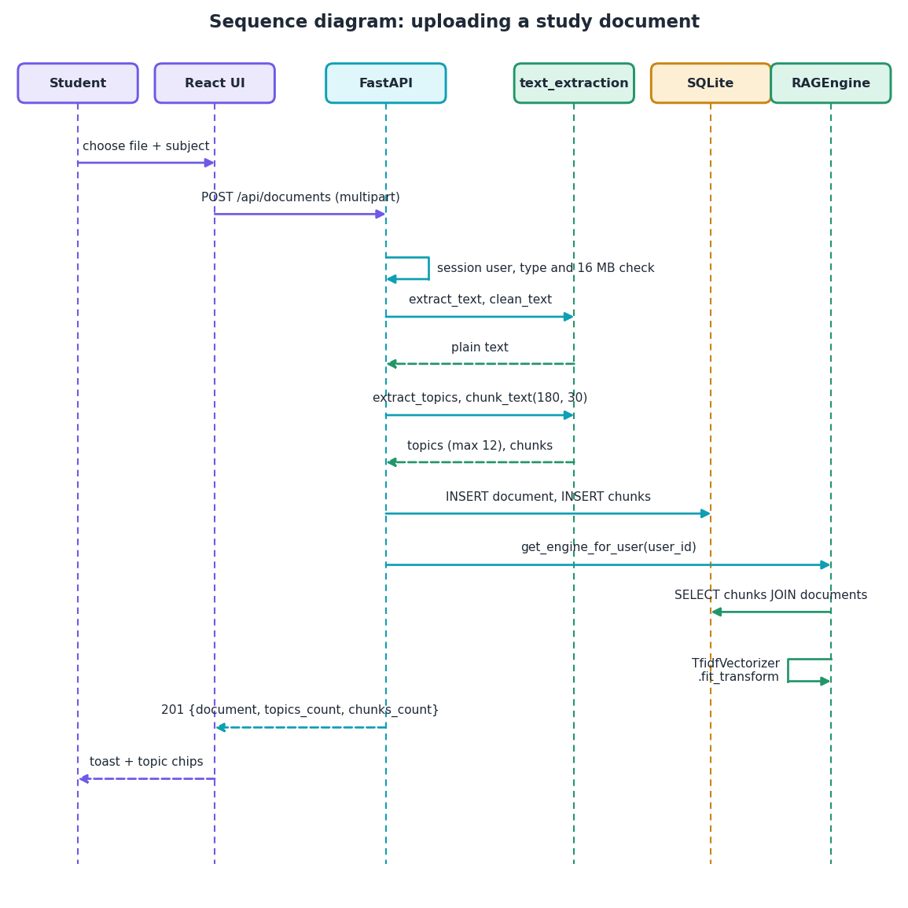
Figure 8: Sequence diagram of uploading a study document.
The student chooses a file and a subject in the browser, and the interface posts them as a multipart request to /api/documents. FastAPI identifies the user from the session cookie and checks the file type and size. It calls the extraction helpers to obtain plain text, then the topic and chunk functions, and inserts the document and chunks into SQLite. It then asks the RAGEngine for the user's engine, which reads the chunks joined with the document names and fits a new TF-IDF vectorizer. The response (status 201) carries the document, the number of topics and the number of chunks, which the interface turns into a toast and a list of topic chips.

Sequence diagram: ask a question
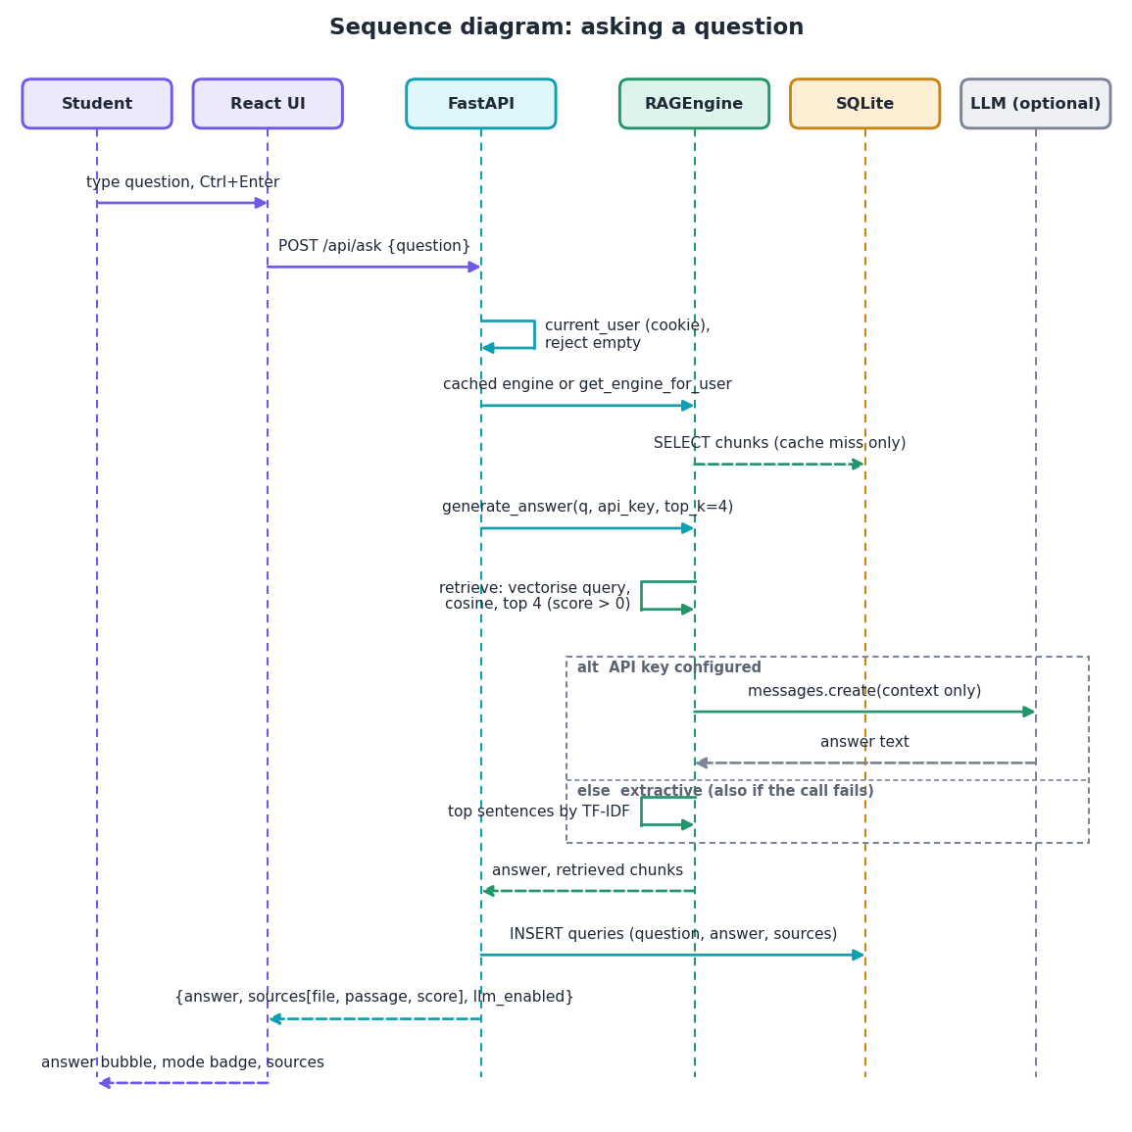
Figure 9: Sequence diagram of asking a question.
The student types a question and sends it with Ctrl+Enter. FastAPI checks the session and rejects an empty question, then takes the cached engine or builds it (a read of the chunks happens only on a cache miss). generate_answer retrieves the four best chunks. The framed alternative shows the two answer paths: if an API key is configured, the context is sent to the language model; otherwise, and also when the call fails, the extractive method picks the highest-ranked sentences. The result is stored in the queries table and returned with the sources, which the interface shows as an answer bubble, a mode badge and a collapsible list of passages with their match scores.

Use case diagram
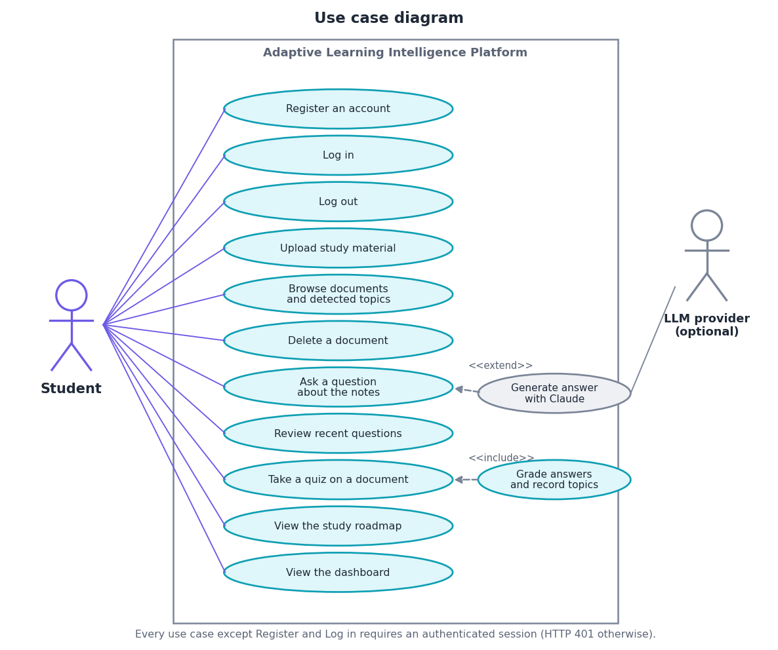
Figure 10: Use case diagram: one actor, eleven use cases and one optional external actor.
The student is the only actor of the platform. The use cases are registering, logging in and out, uploading study material, browsing documents with their detected topics, deleting a document, asking a question, reviewing recent questions, taking a quiz, viewing the roadmap and viewing the dashboard. Asking a question can be extended by generating the answer with Claude, which involves the optional language-model provider; taking a quiz includes grading the answers and recording the topics. Every use case except registration and login needs an authenticated session, and the server answers 401 otherwise.

Entity-relationship diagram
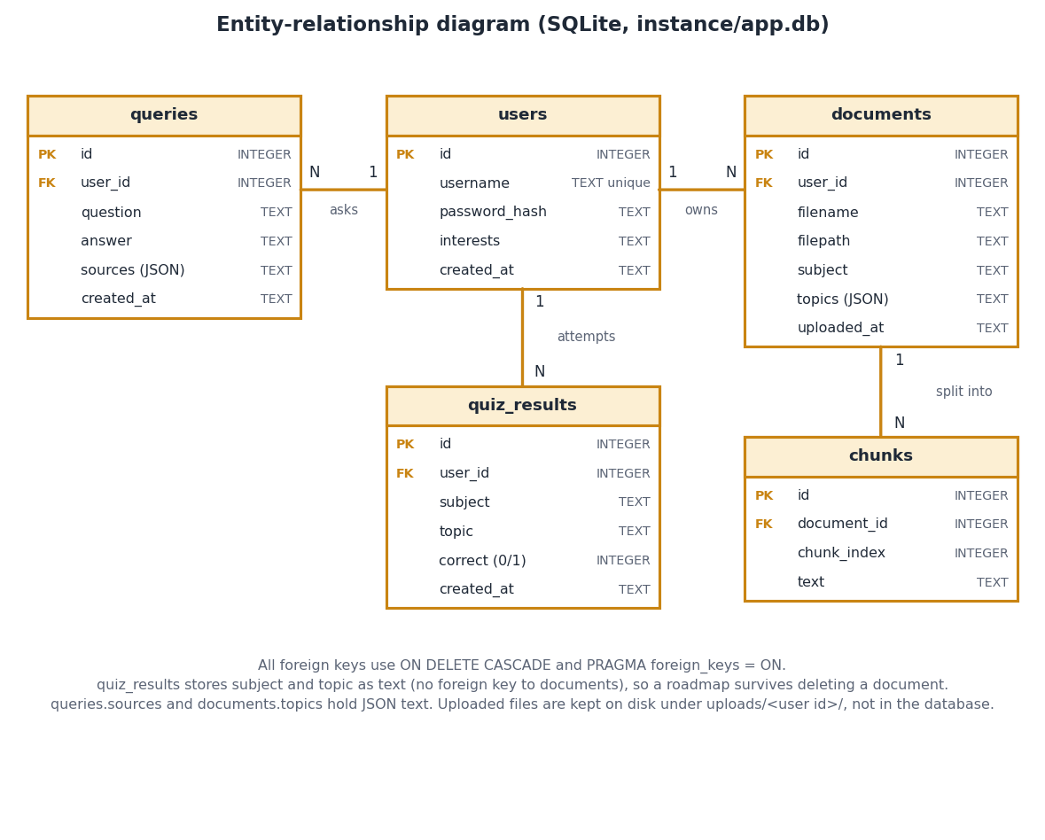
Figure 11: Entity-relationship diagram of the SQLite database.
The database has five tables. users is the parent of documents, queries and quiz_results through the foreign key user_id; documents is the parent of chunks through document_id. All foreign keys cascade on delete and foreign-key checking is switched on, so deleting a document removes its chunks. quiz_results stores the subject and topic as text instead of referring to a document, so a roadmap survives deleting the document it came from. The topics of a document and the sources of a query are stored as JSON text.

Flowchart: answering a question
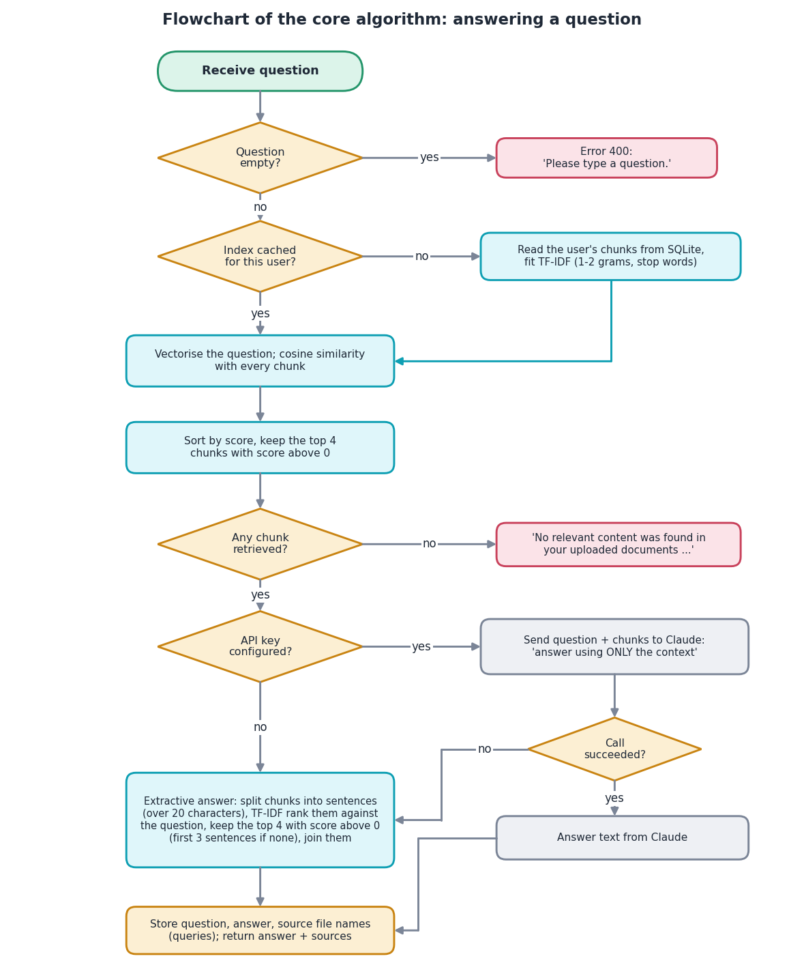
Figure 12: Flowchart of the core algorithm: retrieval and answer generation.
The flowchart is the core algorithm of the platform. An empty question ends with error 400. Otherwise the user's index is taken from the cache or built from the stored chunks. The question is vectorised, cosine similarity is computed with every chunk, and the four best chunks with a score above zero are kept. If none remains, the fixed message "No relevant content was found in your uploaded documents" is returned. If an API key is configured, the question and chunks are sent to the language model with the instruction to answer using only the context; a successful call gives the answer, and a failure falls through to the extractive branch. The extractive branch splits the chunks into sentences longer than 20 characters, ranks them by TF-IDF cosine against the question, keeps the top four with a positive score (the first three sentences if none is positive) and joins them. In every case the question, answer and source file names are stored before the response is returned.

Flowcharts: quiz generation and roadmap
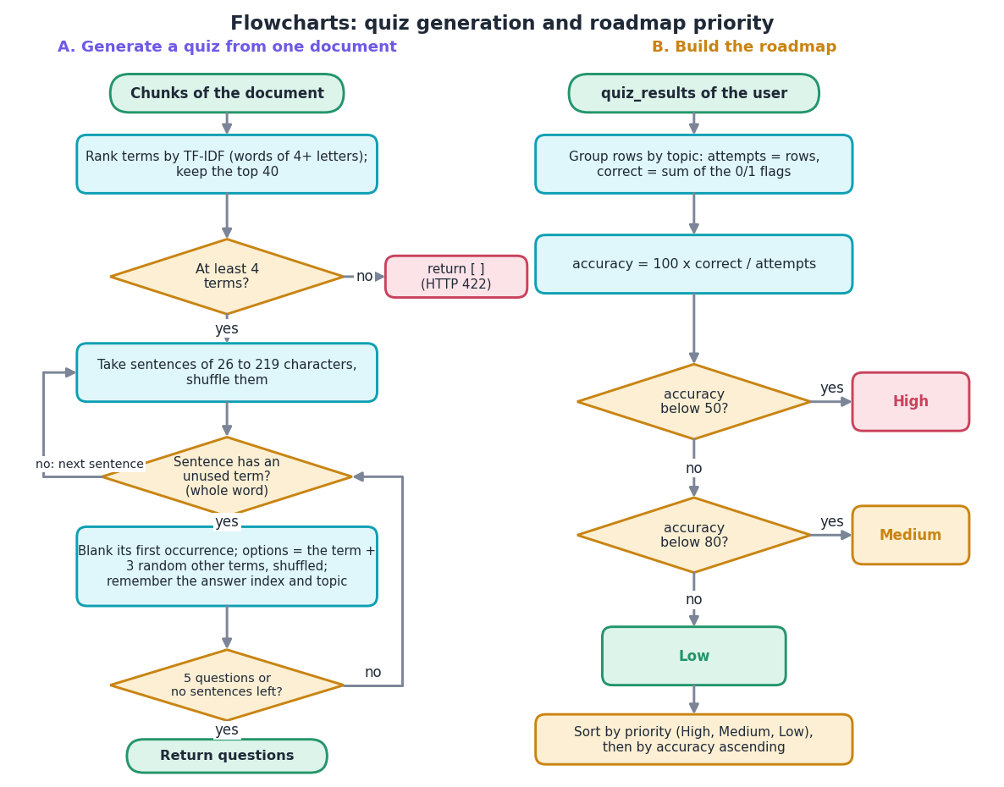
Figure 13: Flowcharts of quiz generation (left) and the roadmap priority rule (right).
Panel A shows quiz generation. The words of at least four letters of the document are ranked by TF-IDF and the top 40 kept; fewer than four terms means no quiz (HTTP 422). Sentences between 26 and 219 characters are shuffled; for each sentence the first term that is not used yet and occurs as a whole word is blanked at its first occurrence, three other terms become distractors, and the four options are shuffled. The loop stops after five questions or when sentences run out. Panel B shows the roadmap: quiz rows are grouped by topic, accuracy is 100 x correct / attempts, and topics below 50 percent are High, below 80 percent Medium and the rest Low; the list is sorted by priority and then by accuracy.

